Please go the the file panel-edit.html

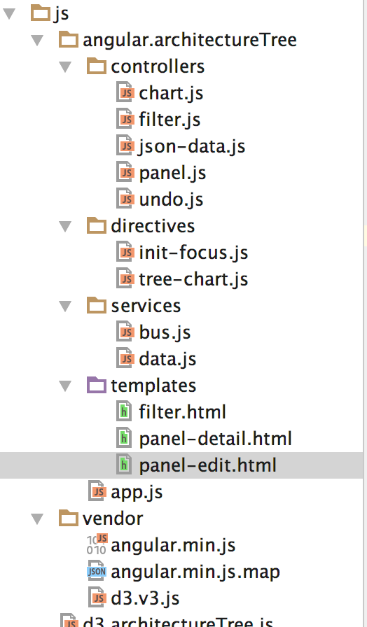

To make changes on ADD,MOVE,CANCEL

Open this file and you will see around the bottom of the document. There is add , move as shown in fig below.

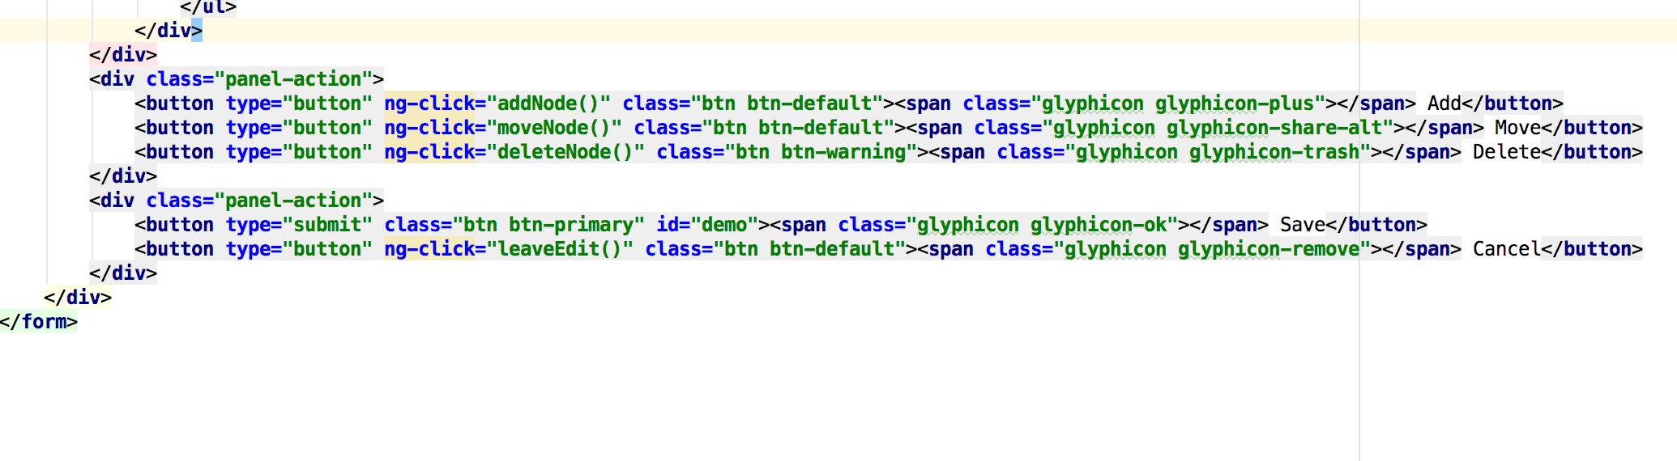

TO Change the name of DEPENDS ON, Dependendents,Technos, Host, panel-detail.html



